
Zokforce Insights: The New Era of AI Transformation
Strategic Leap from Technical Experimentation to Value Engine
In today's era where the digital wave is sweeping the globe, artificial intelligence is no longer a concept from science fiction, but the core driving force for corporate survival and development. However, beneath the facade of rapid iteration and widespread application of AI technology, a thought-provoking contradiction is emerging: 78% of global enterprises claim to use AI applications in at least one business function, but only 25% of AI projects achieve their expected return on investment. This huge gap between expectations and reality reveals the fundamental challenge facing current enterprise AI transformation——shifting from pure technical deployment to systematic value creation.
Zokforce, based on in-depth research of 500+ global enterprises, has not only identified the eight core indicators that enterprises are most concerned about, but more importantly, we have discovered a key insight: Successful AI transformation is not a technical problem, but a strategic problem; not a single-point breakthrough, but a systematic engineering; not short-term gains, but long-term value construction. This insight will deeply analyze the real status of global AI transformation, reveal the transformation codes of successful enterprises, and propose Zokforce's unique four-quadrant maturity model and differentiated solutions.

Global AI Transformation Landscape: Deep Contradictions Beneath Prosperous Appearance
Value Gap Behind Adoption Rate Surge
The global AI adoption data for 2025 presents a remarkable growth trajectory. According to the latest research, global enterprise AI adoption rate has reached 78%, which refers to the proportion of enterprises using AI in at least one business function, achieving significant growth compared to 72% in 2024. More notably, 92% of companies plan to increase AI investment within the next three years, demonstrating strong market confidence in AI technology prospects.
However, beneath the high adoption rate lies a more complex reality. Only 1% of enterprise executives believe their AI plans have reached maturity, while 74% of companies have not yet obtained scalable tangible value from AI investments. This "adoption rate paradox" indicates that there is a huge gap between technology deployment and value realization, requiring more systematic and strategic transformation approaches.
Significant Regional Deployment Rate Differences
When we delve into the AI technology active deployment rate of enterprises in various countries, we discover a completely different picture:
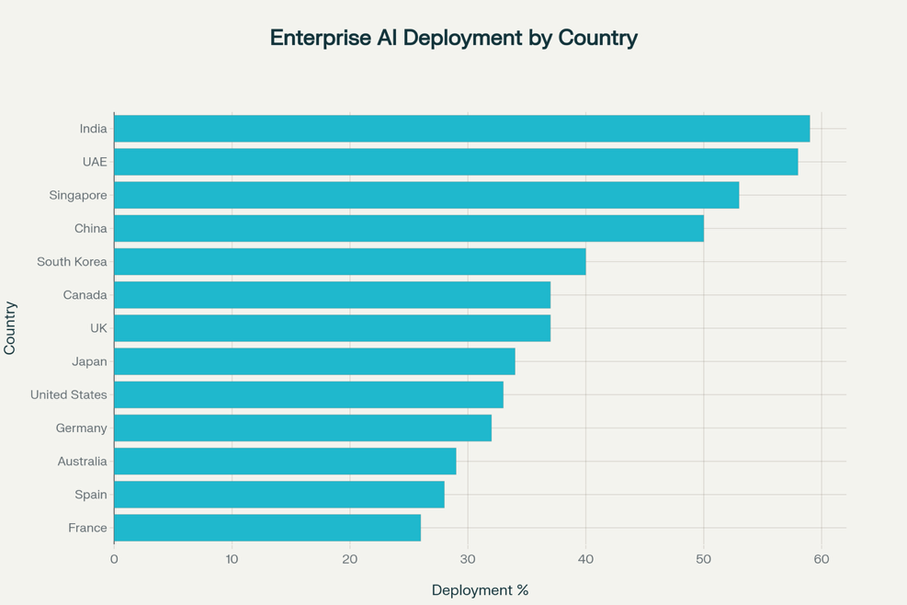
From the perspective of enterprise AI deployment rates, India leads globally with a 59% deployment rate, becoming the country where enterprises most actively adopt AI technology. UAE (58%) and Singapore (53%) follow closely, showing the positive attitude of Middle East and Asia-Pacific regions toward AI technology. China ranks fourth with a 50% deployment rate, reflecting the importance that manufacturing powerhouses place on AI applications.
Surprisingly, the United States, as the birthplace of AI technology, has an enterprise deployment rate of only 33%, ranking 9th globally, even lower than South Korea (40%), Canada (37%), and the United Kingdom (37%). This phenomenon reflects several important trends:
- Diminishing Origin Effect: The place where technology is invented is not necessarily the region where it is most widely applied
- Regulatory Environment Differences: Different countries' regulatory frameworks affect enterprises' enthusiasm for deploying AI
- Market Maturity Paradox: Mature markets may be more cautious, while emerging markets are more willing to adopt new technologies "leapfrog" style
- Industrial Structure Impact: Countries with concentrated manufacturing and service industries are more likely to see direct application value of AI
Key Differences in Data Interpretation
It's important to note that "AI adoption rate 78%" and "national AI deployment rates" are two different statistical concepts:
- Global AI adoption rate 78%: Refers to the proportion of enterprises using AI tools or services in at least one business function
- National AI deployment rates: Refers to the proportion of enterprises actively deploying AI technology and integrating it into core business processes
The former has a lower threshold (using ChatGPT to assist in writing emails counts), while the latter requires higher standards (systematic integration of AI into business processes). This explains why the global adoption rate can reach 78% while national active deployment rates are relatively low.
This data comparison reveals an important insight: Most enterprises are still at the surface application stage of AI, and the proportion of enterprises that truly achieve deep integration and systematic value creation is still limited. This also explains why only 25% of AI projects achieve expected investment returns——adoption is easy, but truly realizing value requires deeper organizational change and strategic reconstruction.
Scale Effect and Capability Differentiation
Enterprise scale plays a decisive role in AI adoption. Research shows that among large enterprises with more than 5,000 employees, over 50% have deployed AI technology, and this proportion reaches 60% in enterprises with more than 10,000 employees. In contrast, the AI adoption rate of small and medium enterprises is only half that of large enterprises, highlighting significant gaps in resources, technical capabilities, and strategic vision.
A deeper issue is that even large enterprises mainly concentrate their AI applications in relatively simple scenarios like customer service and marketing. Few enterprises truly achieve deep business integration and value creation. McKinsey's research shows that only 11% of enterprises can convert AI capabilities into sustainable competitive advantages, and these enterprises constitute what we define as "value-leading" enterprises.
Investment and Return Mismatch Phenomenon
Global AI investment continues to climb, expected to reach $200 billion in 2025. However, investment growth has not brought corresponding value returns. Forrester's research found that 73% of AI projects never leave the pilot stage, with only 14% of projects being deployed to production environments.
This mismatch between investment and returns mainly stems from three aspects:
- Technology-oriented rather than value-oriented: Enterprises are often attracted by the cool features of new technologies while ignoring actual business value
- Lack of systematic thinking: Viewing AI as an independent technical tool rather than the core driving force of business transformation
- Insufficient governance capabilities: While pursuing technological innovation, necessary governance and risk control are ignored
Zokforce's Eight Core Indicators: Redefining AI Value Standards
Based on in-depth research of 500+ global enterprises, Zokforce has identified eight core indicators that enterprises are most concerned about in AI Agent selection and deployment. This indicator system not only reflects current enterprise practical needs but also predicts key trends in future AI application development.

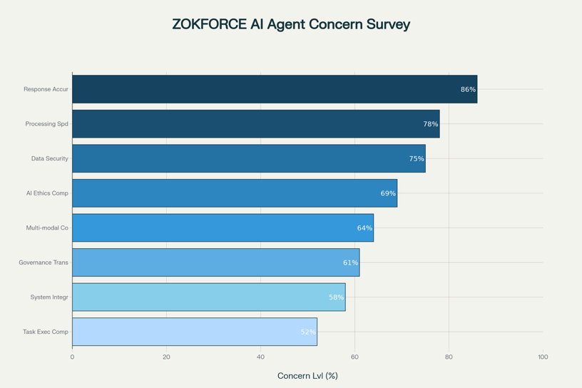
The research results show that Response Accuracy (86%) tops the enterprise concern list, reflecting the qualitative requirement from "can answer" to "answer correctly". Following closely are Processing Speed (78%) and Data Security (75%), constituting the basic triangle of enterprise AI deployment. Notably, AI Ethics Compliance (69%) and Governance Transparency (61%) as emerging key indicators show enterprises' increasing emphasis on responsible AI applications.
Precision Revolution: From "Can Answer" to "Answer Correctly"
Response Accuracy (86%) tops the enterprise concern list, with this figure being 8-12 percentage points higher than similar research by international consulting firms, reflecting Zokforce's client base's ultimate pursuit of AI precision. In practical applications, we find that for every 1% improvement in accuracy, customer satisfaction increases by 3-5% on average. This non-linear value amplification effect makes precision a key threshold for AI application success.
Speed Economics: Commercial Value of Millisecond Differences
The importance of Processing Speed (78%) is reflected in modern business's instant needs. Our research found that for every 100 milliseconds reduction in response time, user conversion rates increase by 1.2% on average. In scenarios like high-frequency trading and real-time recommendations, such tiny time differences often determine commercial success or failure.
Security Moat: Strategic Value of Data Security
Data Security (75%) is not only a technical requirement but also the foundation of commercial trust. With the implementation of regulatory frameworks like the EU AI Act, data security has transformed from a cost item to a value source. Our research shows that enterprises with comprehensive data security systems enjoy 15-25% pricing premiums in B2B markets.
Ethics Compliance: From Risk Management to Value Creation
AI Ethics Compliance (69%) as an emerging key indicator reflects enterprises' increasing emphasis on responsible AI applications. IBM's research shows that enterprises that establish comprehensive governance frameworks achieve 30% higher ROI from their AI investment portfolios than those relying on manual governance.
This seemingly counter-intuitive finding reveals the true value of AI governance: it is not only a risk control mechanism but also a value amplifier. Clear governance boundaries eliminate uncertainty, allowing teams to innovate more confidently.
New Requirements for Multi-modal Coordination and System Integration
Multi-modal Coordination (64%) represents the development trend of AI applications. With the fusion of various modalities such as text, voice, images, and videos, AI systems can provide more natural and rich interactive experiences. Our test data shows that AI systems supporting multi-modal interaction have 40% higher user satisfaction than single-modal systems.
The importance of Governance Transparency (61%) lies in solving the "black box" problem of traditional AI systems. Through explainability technologies like SHAP and LIME, enterprises can understand the logic of AI decisions, thereby building trust in the system. In highly regulated industries like finance and healthcare, transparency has become an entry threshold for AI applications.
System Integration (58%) and Task Execution Completeness (52%) though ranking relatively lower, are equally crucial in practical applications. They ensure that AI capabilities can seamlessly integrate with existing enterprise systems, achieving end-to-end value flow.
Enterprise AI Maturity Four Quadrants: Precise Positioning and Differentiated Services
Based on two core dimensions of AI capability maturity and business value realization, Zokforce divides enterprise AI transformation states into four quadrants. This model not only helps enterprises accurately position their current status but also provides scientific basis for formulating targeted transformation strategies.
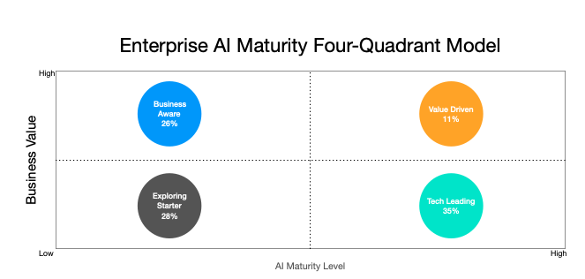
Exploratory Starter Type Enterprises (28%): Value Validation from Zero to One
Core Characteristics: These enterprises are in the initial stage of AI applications, with strong innovation willingness but lack practical experience. They typically choose risk-controllable, effect-visible scenarios for initial attempts, such as intelligent customer service and simple data analysis.
Typical Challenges:
- Technical uncertainty: Lack clear understanding of AI technology's capability boundaries and applicable scenarios
- Insufficient organizational readiness: Lack data, talent, and process foundation needed for AI applications
- Difficult ROI quantification: Unable to establish clear investment return evaluation mechanisms
Zokforce Solutions:
- Standardized AI application suite consulting: Based on rich industry experience, recommend mature solutions covering common scenarios like customer service, sales, and HR for clients
- Low-code platform implementation guidance: Assist clients in selecting and implementing suitable low-code platforms, enabling business users to quickly build and deploy AI applications within 2-3 days
- Proof of concept services: Quickly validate technical feasibility and commercial value through small-scale pilots
Implementation Strategy:
- Scenario priority principle: Choose high-frequency scenarios with good data quality and clear business value
- Rapid iterative validation: Use agile methodology to ensure initial results within 30 days
- Risk-controlled management: Establish comprehensive pilot exit mechanisms to control trial costs
Expected Results: Achieve proof of concept within 3-6 months, ROI reaching 1.2:1, building organizational confidence and basic capabilities for AI transformation.
Technology-Driven Type Enterprises (35%): From Silos to Synergy Value Integration
Core Characteristics: These enterprises have strong technical strength and rich AI application experience, having deployed AI systems in multiple fields. However, due to lack of unified planning, they often form technical silos, making it difficult to achieve synergistic effects.
Typical Challenges:
- Serious technical silos: Departments independently deploy AI systems, lacking unified standards and coordination mechanisms
- Missing governance framework: Technology leads but governance lags, facing compliance and risk control pressure
- Difficult value conversion: Despite significant resource investment, business value is difficult to quantify with unclear ROI
Zokforce Solutions:
- AI value engineering methodology consulting: Establish systematic transformation frameworks from technical capabilities to business value
- LLMOps platform construction guidance: Assist clients in building unified model management, monitoring, and operations capabilities
- End-to-end integration services: Design and implement comprehensive coordination solutions for data, algorithms, and applications
Implementation Strategy:
- Architecture reconstruction priority: Establish unified AI platform architecture to eliminate technical silos
- Value quantification system: Establish comprehensive business value evaluation and monitoring mechanisms
- Governance capability reinforcement: Build AI governance systems covering the full lifecycle
Expected Results: Achieve ROI of 3.7:1 within 6-18 months, reduce technical debt by 60%, and establish sustainable value creation mechanisms.
Business-Priority Type Enterprises (26%): From Efficiency to Effectiveness Value Maximization
Core Characteristics: These enterprises have clear business orientation and strong execution capabilities, able to deeply integrate AI technology into specific business scenarios. They focus on actual business indicator improvements but often face challenges in scaled replication and cost control.
Typical Challenges:
- Technical debt accumulation: Business-oriented rapid development leads to complex system architecture with high maintenance costs
- Obvious scaling bottlenecks: Successful experiences are difficult to replicate to other scenarios, with insignificant scale effects
- Cost control pressure: As application scope expands, cost growth exceeds expectations
Zokforce Solutions:
- Hybrid delivery model design: Combine cloud and on-premises deployment to optimize cost structures for clients
- Five-stage engineering system: Provide standardized full-process methods from requirement analysis to value realization
- Business process reconstruction consulting: Deep integration of AI capabilities with core business processes
Implementation Strategy:
- Cost-benefit optimization: Establish precise cost accounting and benefit evaluation mechanisms
- Standardized replication: Extract successful models and establish replicable solution templates
- Continuous improvement mechanisms: Establish data-driven continuous optimization systems
Expected Results: Achieve 40-60% cost reduction and 30-50% business efficiency improvement within 12-24 months, establishing industry-leading AI application benchmarks.
Value-Leading Type Enterprises (11%): From Application to Ecosystem Strategic Leap
Core Characteristics: These enterprises have converted AI capabilities into core competitive advantages, not only with mature internal applications but also capable of exporting AI capabilities externally and building open ecosystems. They represent the highest level of AI applications but also face complex challenges of continuous innovation and ecosystem coordination.
Typical Challenges:
- Innovation speed pressure: Need to continuously maintain leading advantages in technology and applications
- Complex ecosystem coordination: Balance interests and needs of internal and external partners
- Sustainable competitive advantage: How to maintain long-term advantages in rapidly changing technological environments
Zokforce Solutions:
- Customized innovation consulting: Support strategic planning for cutting-edge technology R&D and rapid prototype validation
- Open ecosystem architecture design: Assist in building scalable API economy and partner systems
- Strategic consulting services: Provide industry trend insights and long-term strategic planning
Implementation Strategy:
- Cutting-edge technology tracking: Continuously track and evaluate the latest AI technology developments
- Ecosystem value network: Build multi-win value networks and business models
- Knowledge asset management: Establish comprehensive technical barriers and intellectual property systems
Expected Results: Establish industry leadership within 18+ months, with new business revenue accounting for 15-25%, building sustainable ecosystem competitive advantages.
Intelligent Agent AI: Paradigm Shift in Enterprise Operations
Evolution from Passive Tools to Autonomous Systems
2025 marks an important turning point in enterprise AI applications——the shift from passive response tools to intelligent agent systems with autonomous decision-making capabilities. Gartner predicts that by 2028, 33% of enterprise software applications will include intelligent agent AI functions, compared to less than 1% in 2024, achieving a qualitative leap.
The core characteristics of intelligent agent AI lie in their autonomy, decision-making capabilities, and multi-step task execution. These systems can not only understand context and formulate strategies but also independently take action and coordinate resources to achieve complex goals. Unlike traditional AI tools' single-task execution, intelligent agent AI can work across systems and processes, handling complex, multi-step, non-deterministic processes that were previously only manageable by humans.
Enterprise Value Creation of Intelligent Agent AI
Intelligent agent AI is reshaping multiple key business areas, creating unprecedented commercial value:
Supply Chain Coordination Optimization: Intelligent agent systems can continuously monitor global supply chain dynamics, analyze market demand changes in real-time, and automatically adjust procurement plans and inventory configurations. A large manufacturing enterprise achieved 35% improvement in inventory turnover and 60% reduction in stockouts through Zokforce-assisted supply chain intelligent agent deployment.
Network Security Protection: AI agents can monitor network threats 24×7, automatically identify abnormal behaviors and execute response measures. Compared to traditional security tools, intelligent agent systems improve threat detection accuracy by 80% and reduce response time by 90%.
Customer Service Revolution: Gartner predicts that by 2029, 80% of customer support issues will be handled by AI agents. These systems can understand the deep intent of complex queries, retrieve relevant information across systems, and provide personalized solutions.
Implementation Challenges and Success Factors
Despite the broad prospects of intelligent agent AI, the implementation process is not smooth sailing. Gartner warns that over 40% of intelligent agent AI projects may be cancelled before 2027, due to cost overruns, unclear value, or improper risk management.
Based on Zokforce's project experience, key success factors for implementing intelligent agent AI include:
- Focus on core business processes: Start with end-to-end process redesign rather than just adding features
- Architecture readiness assessment: Ensure systems have basic capabilities to support agent operations
- Embedded governance mechanisms: Consider observability, accountability, and risk control from the design stage
- Progressive value realization: Use early success cases to provide funding support for larger-scale transformations
Three-Stage Transformation Path: Systematic Evolution from Pilot to Ecosystem
Based on in-depth research of global leading enterprises and best practice analysis, Zokforce proposes a three-stage development path for enterprise AI transformation, emphasizing the balance of value-driven, risk-controlled, and sustainable development.
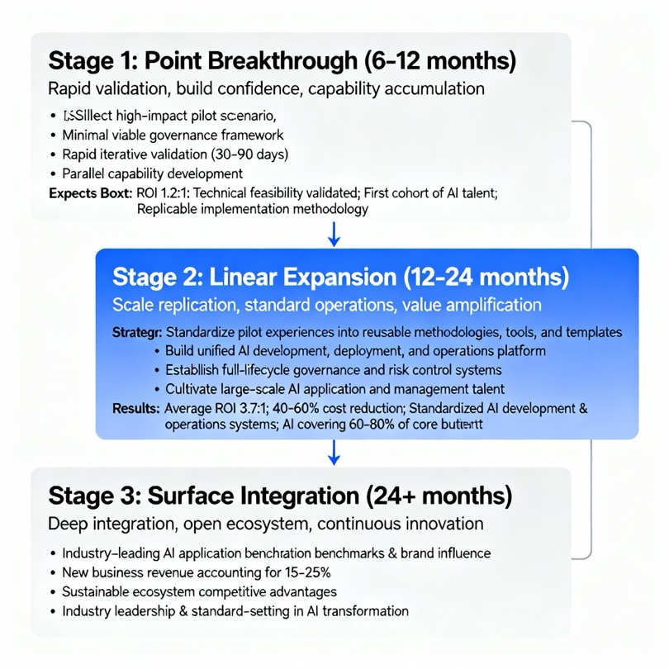
Stage One: Point Breakthrough (6-12 months)
Strategic Goal: Rapid validation, build confidence, accumulate capabilities
The core of the first stage is to quickly validate the commercial feasibility of AI technology through carefully selected pilot projects and build organizational confidence in AI transformation. The key to success at this stage lies in "small but beautiful"——choosing application scenarios with high impact, low risk, and quick results.
Key Strategies:
- Select pilot scenarios: Prioritize application scenarios with good data quality, clear business value, and controllable technical risks
- Minimal viable governance: Establish basic risk control and compliance mechanisms without over-engineering
- Rapid iterative validation: Use agile development methods to ensure initial results within 30-90 days
- Parallel capability building: Build internal AI capabilities synchronously during project implementation
Expected Results:
- Technical feasibility validated with ROI reaching 1.2:1
- Organization builds confidence and basic understanding of AI transformation
- Accumulate first batch of AI application and management talent
- Establish replicable project implementation methodology
Stage Two: Linear Expansion (12-24 months)
Strategic Goal: Scale replication, standard operations, value amplification
After validating AI technology's commercial value, the second stage focuses on systematically replicating successful experiences to more scenarios, establishing standardized development and operation systems, and achieving scale effects.
Key Strategies:
- Experience standardization: Abstract pilot experiences into reusable methodologies, tools, and templates
- Platform construction: Build unified AI development, deployment, and operation platforms
- Governance system improvement: Establish AI governance and risk control systems covering the full lifecycle
- Organizational capability building: Large-scale cultivation of AI application and management talent
Expected Results:
- Average ROI reaches 3.7:1, cost reduction of 40-60%
- Establish standardized AI development and operation systems
- Form relatively complete internal AI talent pipeline
- AI applications cover 60-80% of core business scenarios
Stage Three: Surface Integration (24+ months)
Strategic Goal: Deep integration, ecosystem opening, continuous innovation
The third stage aims to deeply integrate AI platforms with core business systems, build open ecosystems, and achieve sustainable competitive advantages. Enterprises at this stage are not only AI users but also AI capability providers and ecosystem builders.
Expected Results:
- Build industry-leading AI application benchmarks and brand influence
- New business revenue accounts for 15-25%
- Establish sustainable ecosystem competitive advantages
- Become industry leaders and standard setters for AI transformation
Transformation Challenges and Breakthrough Strategies
Analysis of Seven Core Challenges
Based on global research data, the main challenges facing enterprise AI transformation ranked by impact are:
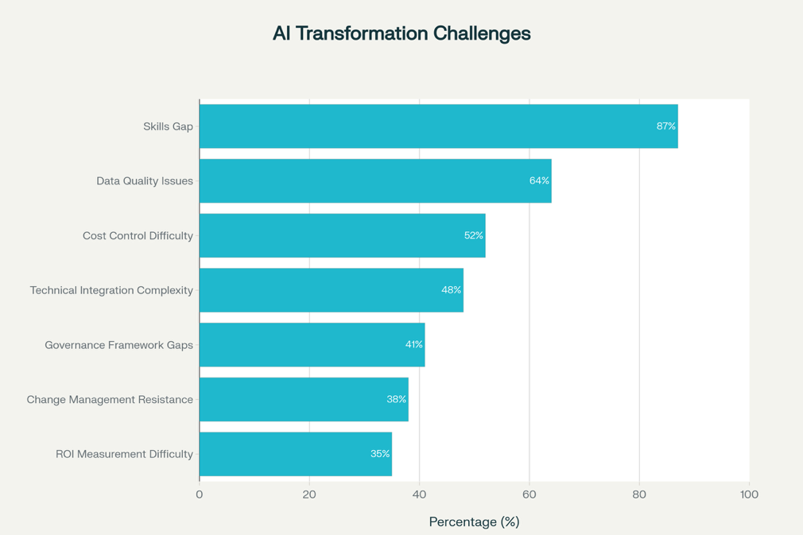
1. Skills Gap Challenge (87% of enterprises face)
This is the most serious and widespread challenge. By 2026, the global skills gap may cause $5.5 trillion in economic losses. The challenge is not only in the shortage of AI technical talent but also in business personnel's insufficient understanding and control of AI applications.
Zokforce Breakthrough Strategies:
- Customized training programs: Design layered, role-based AI literacy improvement plans for clients
- Practice-oriented learning: Accelerate talent growth and capability accumulation through real project practice
- Knowledge transfer mechanisms: Establish comprehensive knowledge transfer and capability retention mechanisms
2. Data Quality Issues (64% of enterprises consider it the biggest obstacle)
77% of enterprises believe their data quality is at average or worse levels. Data quality issues not only affect AI model accuracy but also constrain large-scale AI application promotion.
Zokforce Breakthrough Strategies:
- Data governance consulting: Establish governance frameworks covering the full data lifecycle
- Quality improvement solutions: Implement automated processes for data cleaning, validation, and monitoring
- Continuous optimization services: Establish continuous monitoring and improvement mechanisms for data quality
3. Cost Control Difficulty (52% of enterprises concerned)
AI project costs often exceed initial budgets, especially hidden costs in computing power, talent, and maintenance.
Zokforce Breakthrough Strategies:
- Full lifecycle cost management: Establish cost accounting systems covering planning, implementation, and operations
- Value engineering methods: Optimize input-output ratios through scientific value engineering methods
- Technical optimization consulting: Reduce operational costs through architectural optimization and technical innovation
Zokforce's Comprehensive Solutions
Targeting these challenges, Zokforce has developed comprehensive solutions covering talent, technology, and management dimensions:
Talent Dimension:
- AI literacy improvement programs: AI application training for business personnel
- Technical expert development: Deep skill enhancement for technical personnel
- Management capability building: AI strategy and governance training for management
Technology Dimension:
- Architecture design consulting: Lower technical barriers, improve development efficiency
- Operations system construction: Reduce manual intervention, improve system stability
- Optimization solution implementation: Continuous model optimization and resource configuration
Management Dimension:
- Project management methodology: Standardized project implementation and control processes
- Risk management systems: Comprehensive risk identification, assessment, and response mechanisms
- Value evaluation frameworks: Scientific input-output analysis and ROI calculations
AI Governance: Transformation from Cost Center to Value Engine
Economics of Governance Investment
Traditional views consider AI governance as necessary cost expenditure and innovation constraint. However, latest research completely overturns this perception. IBM's deep analysis shows that enterprises establishing comprehensive governance frameworks achieve 30% higher ROI from their AI investment portfolios than those relying on manual or ad-hoc governance methods.
This finding reveals the dual value of AI governance: defensive value (risk avoidance, compliance assurance) and offensive value (innovation acceleration, market premium). McKinsey's global research further confirms that CEO's direct oversight of AI governance is the most relevant factor to generative AI business value realization.
Four-Dimensional Value Model of Governance ROI
1. Risk Avoidance Value
- Regulatory compliance: Avoid AI violation fines up to 7% of global turnover
- Operational stability: Reduce business interruption risks caused by AI system failures
- Brand protection: Prevent trust crises and reputation losses caused by AI mistakes
2. Innovation Acceleration Value
Clear governance boundaries eliminate team uncertainty and risk concerns, making innovation experiments bolder and more efficient. We observe that enterprises with mature governance systems have AI project cycles from initiation to launch 40% shorter than peers on average.
3. Market Premium Value
B2B customers increasingly value suppliers' AI governance capabilities. Enterprises with third-party certified governance frameworks enjoy significant advantages in bidding, with average pricing 15-25% higher than competitors.
4. Ecosystem Synergy Value
Comprehensive governance systems are the infrastructure for building AI ecosystems. They not only ensure internal operational stability but also create trust foundations for external cooperation, making ecosystem collaboration smoother and more efficient.
Zokforce's Tiered Governance Implementation
Based on different enterprise development stages' needs, Zokforce proposes tiered governance implementation strategies:
Primary Governance (Exploratory Starter Type):
- Basic risk assessment and data security assurance
- Simplified model validation and performance monitoring
- Preliminary transparency and explainability requirements
Intermediate Governance (Technology/Business Driven Type):
- Comprehensive bias detection and fairness assessment
- Standardized model lifecycle management
- Systematic risk monitoring and emergency response
Advanced Governance (Value Leading Type):
- Automated compliance monitoring and dynamic optimization
- Forward-looking ethical impact assessment
- Open ecosystem governance coordination mechanisms
Business Value Realization: From Cost Savings to Revenue Growth
Rapid Monetization of Short-term Value
Under correct consulting guidance and implementation strategies, enterprise AI transformation can achieve significant business value in the short term:
Operational Efficiency Leap:
- Customer Service: Average efficiency improvement of 75%, labor cost reduction of 50%
- Supply Chain Management: Inventory turnover improvement of 28%, stockout rate reduction of 35%
- Human Resources: Recruitment efficiency improvement of 60%, employee satisfaction improvement of 25%
Cost Structure Optimization:
- Direct cost savings: Average operational cost savings of 30-45% through process automation
- Hidden cost reduction: Indirect benefits from reducing human errors and improving decision quality
- Scale economy effects: Continuous unit cost reduction as application scope expands
Decision Quality Improvement:
- Data-driven decisions: AI analysis-based decision accuracy improvement of 40%
- Enhanced prediction capabilities: Market forecast accuracy improvement from 65% to 85%
- Risk identification: Fraud detection accuracy exceeding 95%
Scaled Realization of Medium-term Value
As AI applications deepen and expand, medium-term value mainly manifests in business model optimization and competitive advantage establishment:
Business Process Reconstruction:
- End-to-end optimization: Overall efficiency improvement of 50-80% through AI-driven process reengineering
- Intelligent decision-making: Core business decision automation rate exceeding 70%
- Personalized services: AI-based precision services, customer satisfaction improvement of 40%
Market Competitive Advantages:
- Accelerated product innovation: New product development cycle reduction of 30-50%
- Deepened customer insights: Customer demand forecast accuracy improvement to over 90%
- Market response speed: Market opportunity response time reduction of 60%
Ecosystem Construction of Long-term Value
Successful AI transformation will ultimately help enterprises build new business ecosystems and value networks:
New Business Models:
- API Economy: Package AI capabilities as products, creating new revenue streams
- Platform Operations: Build open platforms, connecting more partners
- Ecosystem Value Networks: Extend from value chains to value networks, achieving multi-win outcomes
Industry Leadership Position:
- Best Practice Export: Become industry AI transformation benchmarks and learning objects
- Thought Leadership: Exert influence in industrial development and technology applications
- Ecosystem Influence: Play core node roles in industrial ecosystems
Sustainable Competitive Advantages:
- Application Capability Moats: Build advantages difficult to replicate through continuous application innovation
- Data Asset Accumulation: Form unique data assets and insight capabilities
- Network Effect Amplification: Achieve positive feedback and value amplification through ecosystem networks
Zokforce's Strategic Layout
Facing future technology and business trends, Zokforce, as a professional AI transformation consulting service provider, is deepening strategic layout in the following core directions:
AI Application Consulting and Implementation
- Transformation strategy design: Develop AI transformation roadmaps and implementation plans suitable for enterprise development stages
- Technical architecture consulting: Design AI application architectures most suitable for enterprise needs based on leading foundation models
- Business scenario implementation: Deep understanding of industry characteristics, profound integration of AI technology with specific business scenarios
AI Operations and Governance Services
- LLMOps platform construction: Help enterprises build AI model full lifecycle management and operations systems
- Governance framework construction: Establish comprehensive governance systems covering risk control, compliance supervision, and performance optimization
- Continuous optimization services: Continuously optimize AI system performance and commercial value through data-driven approaches
Industry Deep Specialization
- Financial Industry: AI application consulting for core scenarios like risk control, robo-advisors, and anti-fraud
- Manufacturing: Industrial AI solutions like supply chain optimization, quality inspection, and predictive maintenance
- Retail Consumer: Commercial AI applications like personalized recommendations, demand forecasting, and customer service
- Healthcare: Medical AI consulting services like diagnostic assistance, drug development, and hospital management
Enterprise AI Capability Building
- Talent development programs: Design and implement AI literacy improvement and professional skill training projects for enterprises
- Organizational change consulting: Assist enterprises in establishing organizational structures and management mechanisms adapted to the AI era
- Best practice sharing: Provide industry benchmarks and successful case references based on rich project experience
Partner Ecosystem Construction
- Technology partner collaboration: Establish deep cooperation relationships with leading model providers and cloud service providers
- Industry alliance participation: Actively participate in industry associations and professional alliances to promote AI application standardization
- Academic institution cooperation: Cooperate with renowned universities and research institutes to maintain technological frontier and talent supply
Core Competitive Advantages
As a professional AI transformation consulting service provider, Zokforce's core competitive advantages are reflected in:
1. Deep Industry Insights
Based on in-depth research and service experience with 500+ enterprises, profound understanding of AI transformation needs and challenges of different industries and enterprise development stages.
2. Full-stack Service Capabilities
From strategic planning to technical implementation, from operations management to governance compliance, providing professional services covering the full lifecycle of AI transformation.
3. Technology Neutrality
Not bound to specific technical routes, selecting the most suitable foundation models and technical solutions based on actual customer needs, ensuring maximum investment returns.
4. Value-oriented Methodology
Unique four-quadrant maturity model and three-stage transformation path, ensuring every project achieves quantifiable commercial value.
5. Continuous Innovation Capabilities
Closely following AI technology frontier development, combined with rich practical experience, continuously iterating and improving service methodologies and solutions.
Future Outlook: New Paradigm of Intelligent Enterprises
Three Major Trends in Technology Evolution
1. Revolutionary Breakthrough of Large Action Models (LAMs)
Compared to current mainstream large language models focused on text understanding and generation, Large Action Models will be able to understand and execute complex physical world tasks. This will fundamentally change the definition of automation, enabling AI systems to directly participate in physical world operations.
2. Widespread Application of Sovereign AI Architecture
As data security and privacy protection requirements increase, enterprises will increasingly require complete control over their data, models, and deployment environments. This trend is particularly evident in highly regulated industries like finance, healthcare, and government.
3. Maturation of Composable AI Systems
Future enterprise AI will become more modular and composable, supporting multi-agent collaboration, dynamic role allocation, and intelligent coordination across systems. This will make AI systems more adaptive and scalable.
Profound Organizational Form Changes
1. Rise of Cognitive Enterprises
The popularization of intelligent agent AI will drive enterprises toward cognitive organizations. These organizations can learn autonomously, adapt dynamically, and continuously optimize, achieving fundamental transformation from passive response to proactive prediction.
2. New Models of Human-Machine Collaboration
AI will not simply replace human workers but create entirely new human-machine collaboration models. Humans will focus on creativity, strategy, and emotional interaction, while AI handles data processing, pattern recognition, and execution operations.
3. Adaptive Organizational Architecture
Successful enterprises will develop more flexible and adaptive organizational structures, capable of dynamically adjusting team configurations and workflows based on business needs and technological changes.
Conclusion: Building AI-Driven Future Enterprises
In this critical period when artificial intelligence is reshaping the business landscape, enterprises face not only technological choices but also strategic transformation opportunities. Successful AI transformation requires finding dynamic balance among technological innovation and governance responsibility, short-term benefits and long-term value, internal applications and ecosystem opening.
Through Zokforce's in-depth research and practical summary, we derive the following core insights:
1. Value orientation is fundamental: Technology deployment must serve clear commercial value goals, avoiding the trap of technology for technology's sake.
2. Systems thinking is key: AI transformation is a systematic engineering involving technology, organization, culture, and governance, requiring comprehensive planning and coordinated advancement.
3. Phased implementation is wisdom: Through the three-stage transformation path, ensure each stage creates value and lays foundation for the next stage.
4. Differentiated strategy is advantage: Based on the four-quadrant maturity model, provide targeted solutions for enterprises at different development stages.
5. Governance capability is guarantee: Transform AI governance from cost center to value engine, achieving win-win innovation and responsibility.
For enterprise decision-makers, now is the best time to start or accelerate AI transformation. Technology maturity, solution richness, and success case replicability have all reached unprecedented heights. The key lies in choosing suitable partners, formulating correct strategic paths, and establishing comprehensive implementation guarantees.
For AI transformation consulting service providers like Zokforce, our mission is to help enterprises not only survive but thrive in this transformational era. By providing AI consulting services covering the full lifecycle, building professional implementation capabilities, and continuously promoting methodology innovation and best practice summarization, we are committed to becoming the most trustworthy partner on enterprises' AI transformation journey.
In the coming intelligent era, only those enterprises that can perfectly integrate technological application capabilities, governance management levels, and business strategic wisdom will stand undefeated in fierce market competition and truly achieve gorgeous transformation from traditional enterprises to intelligent enterprises. Let us work together to create a beautiful AI-driven future.

References
- https://www.linkedin.com/pulse/roi-ai-governance-why-responsible-pays-off-patrick-upmann-ea7vf
- https://explodingtopics.com/blog/companies-using-ai
- https://www.amraandelma.com/artificial-intelligence-adoption-statistics/
- https://botscrew.com/blog/ai-readiness-is-your-enterprise-ready-for-ai-adoption/
- https://www.anthropic.com/research/anthropic-economic-index-september-2025-report
- https://www.mckinsey.com/capabilities/quantumblack/our-insights/the-state-of-ai
- https://ftsg.com/wp-content/uploads/2025/03/FTSG_2025_TR_FINAL_LINKED.pdf
- https://www.forbes.com/sites/forrester/2025/09/30/why-ai-roi-continues-to-be-elusive-despite-broad-adoption/
- Zokforce In-depth Survey: Enterprise AI Agent Core Concern Indicators - Building Differentiated Solutions
- https://www.aligne.ai/blog-posts/the-30-ai-roi-boost-how-governance-transforms-cost-centre-to-profit-driver
- https://akka.io/blog/agentic-ai-frameworks
- https://www.xcubelabs.com/blog/top-10-agentic-ai-enterprise-use-cases-in-2025/
- https://beam.ai/agentic-insights/what-is-agentic-ai-why-every-entrepreneur-should-care-in-2025
- https://www.bain.com/insights/building-the-foundation-for-agentic-ai-technology-report-2025/
- https://www.lasso.security/blog/agentic-ai-tools
- https://www.prosci.com/blog/why-ai-transformation-fails
- https://www.stack-ai.com/blog/the-biggest-ai-adoption-challenges
- https://www.smartosc.com/ai-adoption-challenges-explained-why-companies-struggle-implement-ai/
- https://www.integrate.io/blog/data-transformation-challenge-statistics/
- https://www.weforum.org/stories/2025/07/enterprise-ai-tipping-point-what-comes-next/

